**Industrial Internship Report on**

**”Multi-client website offering client services”**

**Prepared by**

**NIDARSHANA K S**

| *Executive Summary* |
| --- |
| This report provides details of the Industrial Internship provided by upskill Campus and The IoT Academy in collaboration with Industrial Partner UniConverge Technologies Pvt Ltd (UCT).  This internship was focused on a project/problem statement provided by UCT. We had to finish the project including the report in 6 weeks’ time.  My project was a multi-client service platform that enables merchants to create their own stores, showcasing products with images, descriptions, and pricing. Customers can browse by category, purchase products, and complete transactions through a secure payment gateway. Merchants have a dashboard to manage inventory, orders, and customer interactions. A scalable multi-tenant structure ensures seamless expansion, with admin tools for managing users, categories, and platform operations.  This internship gave me a very good opportunity to get exposure to Industrial problems and design/implement solutions for that. It was an overall great experience to have this internship. |

**TABLE OF CONTENTS**

1 Preface 3

2 Introduction 4

2.1 About UniConverge Technologies Pvt Ltd 4

2.2 About upskill Campus 8

2.3 Objective 9

2.4 Reference 9

2.5 Glossary 10

3 Problem Statement 11

4 Existing and Proposed solution 12

5 Proposed Design/ Model 13

5.1 High Level Diagram (if applicable) 13

5.2 Low Level Diagram (if applicable) 13

5.3 Interfaces (if applicable) 13

6 Performance Test 14

6.1 Test Plan/ Test Cases 14

6.2 Test Procedure 14

6.3 Performance Outcome 14

7 My learnings 15

8 Future work scope 16

# Preface

Over the past six weeks, I had the opportunity to work on a **multi-client service platform**, where I focused on developing a scalable marketplace that enables merchants to showcase and sell their products. This internship has been an incredible learning experience, enhancing my technical skills, problem-solving abilities, and understanding of real-world project development.

Internships play a crucial role in shaping a student's career by providing hands-on experience, industry exposure, and the ability to apply theoretical knowledge to practical problems. This experience has helped me bridge the gap between academics and the professional world while improving my technical and soft skills.

The project aimed to build a **multi-client service platform** where multiple merchants could sign up, create their own stores, and sell products. The key challenges involved implementing a **secure checkout process, integrating a payment gateway, managing product listings**, and ensuring a smooth user experience for both merchants and customers.

I am incredibly grateful to **[USC/UCT]** for providing me with this opportunity to work on a real-world project under expert guidance. The program structure, mentorship, and resources helped me gain valuable insights into full-stack development and marketplace management.

The program was well-structured, with a clear roadmap that included ,Initial research and project understanding.Designing the platform architecture and setting up the database.Developing core functionalities such as merchant registration, product listing, and order processing.Integrating a secure payment gateway and enhancing user experience.Testing, debugging, and deploying the platform for seamless operation.

During this internship, I significantly enhanced my technical skills, gaining expertise in **MERN stack development, database management, and payment gateway integration**. I also developed strong **problem-solving abilities**, tackling various project challenges efficiently and learning how to implement effective solutions. Additionally, I improved my **project management skills**, understanding how to plan, execute, and deliver a project within deadlines. Moreover, working in a team-oriented environment helped me appreciate the importance of **collaboration, teamwork, and communication**, which are essential for successful project execution and professional growth.

# Introduction

## About UniConverge Technologies Pvt Ltd

A company established in 2013 and working in Digital Transformation domain and providing Industrial solutions with prime focus on sustainability and RoI.

For developing its products and solutions it is leveraging various**Cutting Edge Technologies e.g. Internet of Things (IoT), Cyber Security, Cloud computing (AWS, Azure), Machine Learning, Communication Technologies (4G/5G/LoRaWAN), Java Full Stack, Python, Front end**etc.

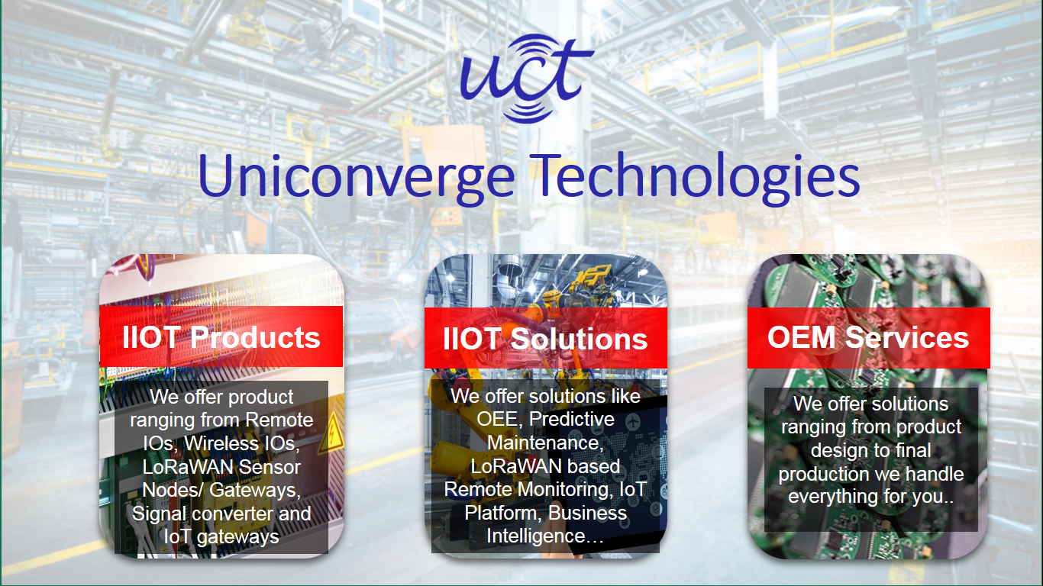

1. **UCT IoT Platform (****)**

**UCT Insight** is an IOT platform designed for quick deployment of IOT applications on the same time providing valuable “insight” for your process/business. It has been built in Java for backend and ReactJS for Front end. It has support for MySQL and various NoSql Databases.

* It enables device connectivity via industry standard IoT protocols - MQTT, CoAP, HTTP, Modbus TCP, OPC UA
* It supports both cloud and on-premises deployments.

It has features to  
• Build Your own dashboard  
• Analytics and Reporting  
• Alert and Notification  
• Integration with third party application(Power BI, SAP, ERP)  
• Rule Engine

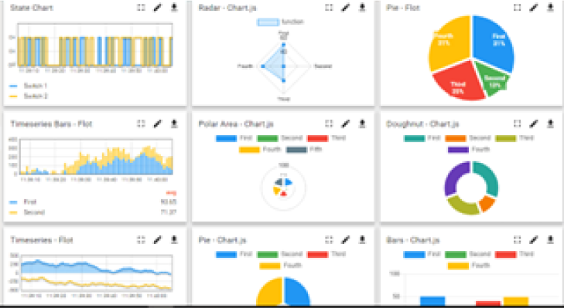 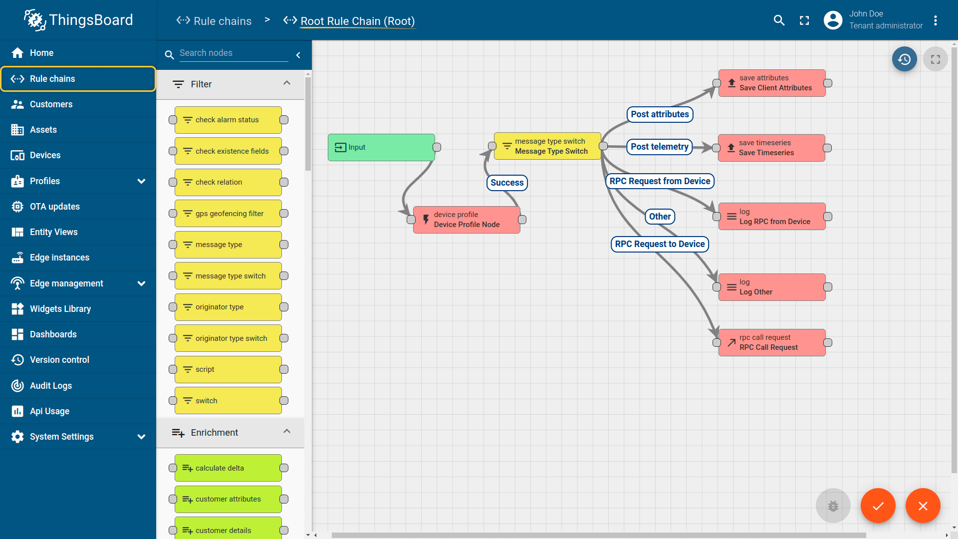

1. **Smart Factory Platform (****)**

Factory watch is a platform for smart factory needs.

It provides Users/ Factory

* with a scalable solution for their Production and asset monitoring
* OEE and predictive maintenance solution scaling up to digital twin for your assets.
* to unleased the true potential of the data that their machines are generating and helps to identify the KPIs and also improve them.
* A modular architecture that allows users to choose the service that they what to start and then can scale to more complex solutions as per their demands.

Its unique SaaS model helps users to save time, cost and money.

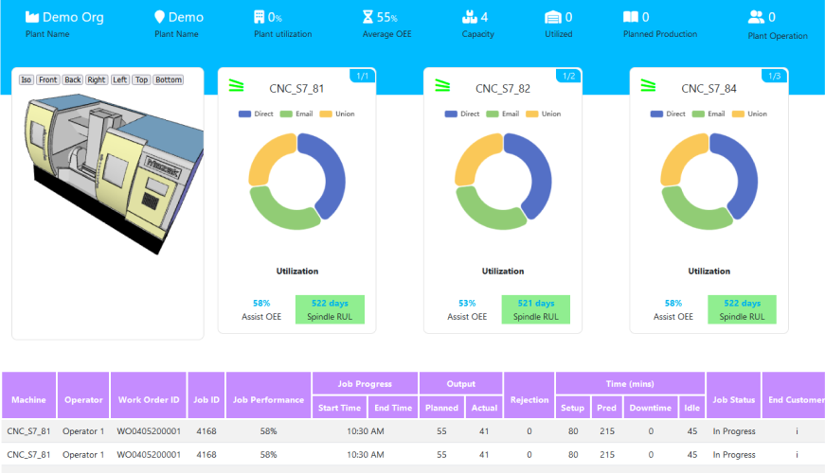 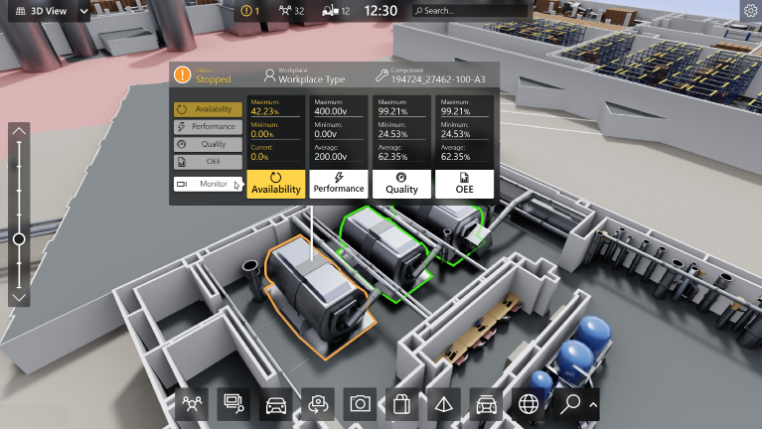

1.  based Solution

UCT is one of the early adopters of LoRAWAN teschnology and providing solution in Agritech, Smart cities, Industrial Monitoring, Smart Street Light, Smart Water/ Gas/ Electricity metering solutions etc.

1. Predictive Maintenance

UCT is providing Industrial Machine health monitoring and Predictive maintenance solution leveraging Embedded system, Industrial IoT and Machine Learning Technologies by finding Remaining useful life time of various Machines used in production process.

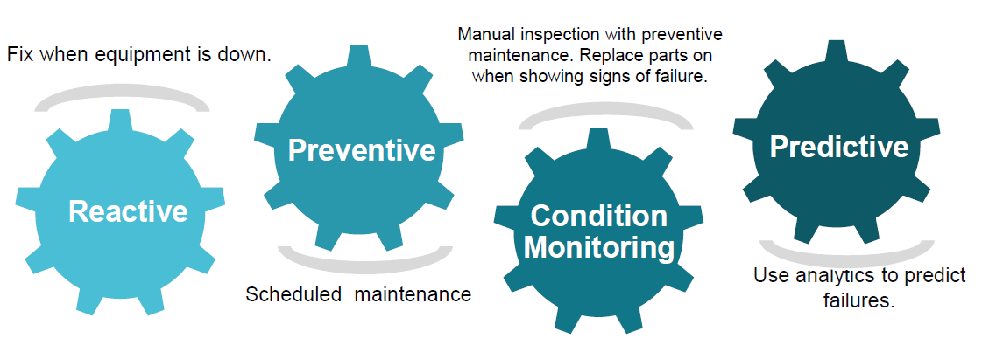

## About upskill Campus (USC)

upskill Campus along with The IoT Academy and in association with Uniconverge technologies has facilitated the smooth execution of the complete internship process.

USC is a career development platform that delivers **personalized executive coaching** in a more affordable, scalable and measurable way.



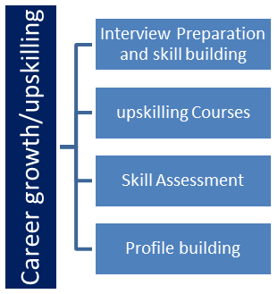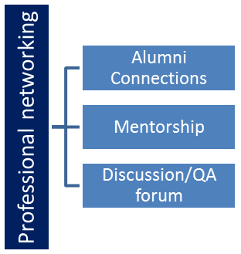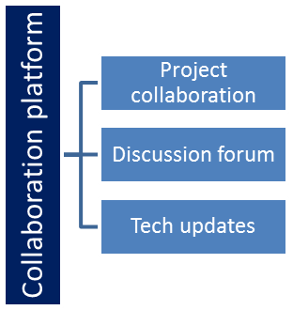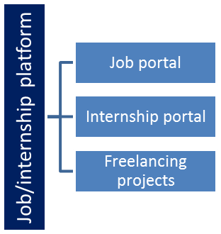

## The IoT Academy

The IoT academy is EdTech Division of UCT that is running long executive certification programs in collaboration with EICT Academy, IITK, IITR and IITG in multiple domains.

## Objectives of this Internship program

The objective for this internship program was to

 ☛ get practical experience of working in the industry.

 ☛ to solve real world problems.

 ☛ to have improved job prospects.

 ☛ to have Improved understanding of our field and its applications.

 ☛ to have Personal growth like better communication and problem solving.

## Reference

[1] Referred to official MongoDB, Express.js, React.js, and Node.js documentation for best practices and troubleshooting..

[2] Followed online tutorials and courses on platforms like Udemy, freeCodeCamp, and MDN to enhance MERN stack proficiency.

[3] Engaged in GitHub repositories, Stack Overflow discussions, and MERN developer forums for problem-solving

## Glossary

| Terms | Acronym |
| --- | --- |
| MERN | Mongodb,Express JS,React JS,Node JS |
| CRUD | Create, Read, Update, Delete |
| JWT | JSON Web Token |

# Problem Statement

### 

In today's digital marketplace, small and medium-sized businesses face challenges in establishing an online presence, managing product listings, and securely processing transactions. Existing e-commerce solutions often lack flexibility for merchants to create personalized stores and struggle with multi-tenant scalability.

This project aims to develop a multi-client service platform that enables multiple merchants to create and manage their online stores, list products, and process secure transactions seamlessly. Customers can browse categorized products, purchase items through an integrated payment gateway, and track their orders efficiently. The platform ensures scalability, security, and user-friendly management tools, allowing merchants to handle inventory, orders, and customer interactions with ease.

By building a robust, multi-tenant architecture, this platform provides an accessible and efficient solution for businesses to digitally transform their sales process while enhancing the overall customer shopping experience.

### 4.Existing Solution

Currently, many small and medium-sized businesses rely on third-party e-commerce platforms such as Amazon, Shopify, and WooCommerce to sell their products. While these platforms provide a marketplace, they come with several challenges:

1. **High Commission Fees** – Many platforms charge significant fees per transaction, reducing profit margins for merchants.
2. **Limited Customization** – Merchants have minimal control over store design, branding, and customer interactions.
3. **Complex Onboarding** – Setting up a store can be cumbersome, requiring technical expertise or additional costs.
4. **Scalability Issues** – Some platforms do not support seamless growth for businesses looking to expand.
5. **Lack of Direct Customer Interaction** – Many third-party marketplaces restrict communication between merchants and customers, affecting personalized service.

### Proposed Solution

To address these challenges, our **multi-client e-commerce platform** offers a **scalable and cost-effective** solution for merchants to create and manage their online stores efficiently. Key features of the proposed solution include:

1. **Dedicated Merchant Stores** – Each merchant gets a personalized storefront to showcase their products, pricing, and branding.
2. **Seamless Onboarding** – A user-friendly registration and setup process allows merchants to start selling quickly.
3. **Integrated Payment Gateway** – Secure transactions using **Stripe, PayPal, or Razorpay** ensure smooth checkout experiences.
4. **Inventory & Order Management** – Merchants can easily update stock, track sales, and manage orders from a centralized dashboard.
5. **Direct Customer Interaction** – Merchants can communicate with customers for personalized service and order updates.
6. **Scalability & Multi-Tenant Support** – The platform is designed to handle multiple merchants and customers efficiently, ensuring smooth performance as the user base grows.
7. **Cost-Effective & Commission-Free** – Unlike third-party marketplaces, our solution minimizes transaction fees, maximizing merchant profits.

## Code submission (Github link):https://github.com/NidarshanaKS/upskillcapmus

## Report submission (Github link):https://github.com/NidarshanaKS/upskillcapmus

## 

# Proposed Design/ Model

The platform follows a **multi-tenant architecture** using the **MERN Stack** (MongoDB, Express.js, React.js, Node.js), enabling multiple merchants to create and manage their online stores.

#### Key Components:

**Frontend (React.js)** – Customer and merchant dashboards for product browsing, order management, and store customization.  
 **Backend (Node.js & Express.js)** – Handles authentication (JWT), order processing, and API interactions.  
 **Database (MongoDB)** – Stores users, products, orders, and reviews.  
 **Payment Integration** – Secure transactions via **Stripe, PayPal, or Razorpay**.

#### Workflow:

* **Merchants**: Register, create stores, list products, manage inventory, and track orders.
* **Customers**: Sign up, browse products, add to cart, complete secure payments, track orders, and leave reviews.

## 

## 

# 5.My learnings

### My Learnings from the Project

During this project, I gained valuable insights into **full-stack development, project management, and real-world problem-solving**. Here are my key takeaways:

**Technical Skills** – Improved expertise in **MERN stack (MongoDB, Express.js, React.js, Node.js)**, database management, and secure payment gateway integration.

**Scalability & Performance Optimization** – Learned to handle **high traffic loads**, optimize **API response times**, and implement **caching techniques** for better efficiency.

**Security Best Practices** – Understood the importance of **JWT authentication, data encryption, secure API handling, and fraud prevention** in e-commerce transactions.

**Problem-Solving & Debugging** – Gained hands-on experience in troubleshooting issues related to **database queries, UI responsiveness, and order processing workflows**.

**Project Planning & Execution** – Developed skills in **requirement analysis, system design, workflow structuring, and testing methodologies** to deliver a successful project.

**Collaboration & Teamwork** – Learned how to **communicate effectively, coordinate tasks, and work in a professional environment** with mentors, peers, and team members.

# Future work scope

While the project successfully delivers a **scalable and secure multi-client service platform**, there are several areas for future improvements and enhancements:

**1. AI-Based Product Recommendations** – Implementing **machine learning algorithms** to provide personalized product suggestions for customers based on their browsing and purchase history.

**2. Advanced Search & Filtering** – Enhancing search functionality with **natural language processing (NLP), voice search, and AI-powered filtering** for a better user experience.

**3. Multi-Currency & Global Payment Support** – Expanding the platform to support **multiple currencies, region-based pricing, and additional payment gateways** for international transactions.

**4. Automated Inventory Management** – Integrating AI-driven stock prediction to help merchants optimize their inventory levels and avoid overstocking or shortages.

**5. Progressive Web App (PWA) & Mobile App** – Developing a **mobile-friendly version** of the platform or a dedicated app for better accessibility and engagement.